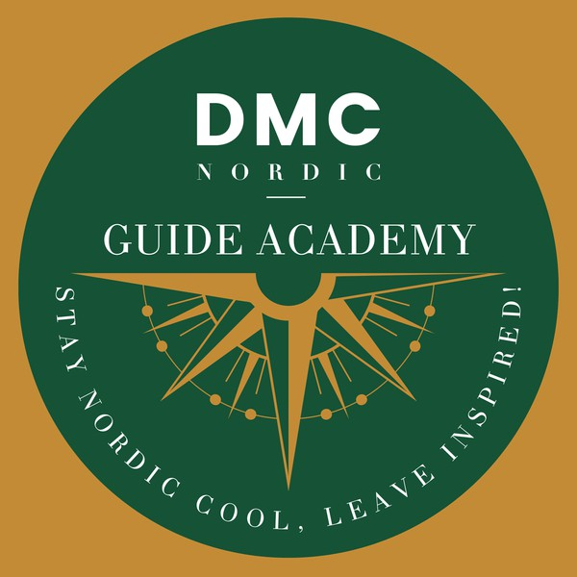

APPLICATION FORM FOR NORDIC GUIDE ACADEMY'S GUIDE COURSE SEPTEMBER 2025 - May 2026

*We appreciate your interest in our guide training program. Please kindly fill in all requested information and answer all the questions below. This Application form has to be sent when sending the application email*

**Personal information**

Name Address Email

Phone

**Question 1.** What is your professional background ?



**Question 2.** What is your motivation for attending this training program?



**Question 3.** Do you have any previous experience in guiding, teaching or performing?



**Question 4.** Do you have any special passions? Nature/history/ art etc?



**Question 4.** Do you speak any other language than English?

**Question 4.** Any further comments:

We will be pleased to invite you for an informal dialogue in a group to discuss a question or a subject typically raised by our tourists.